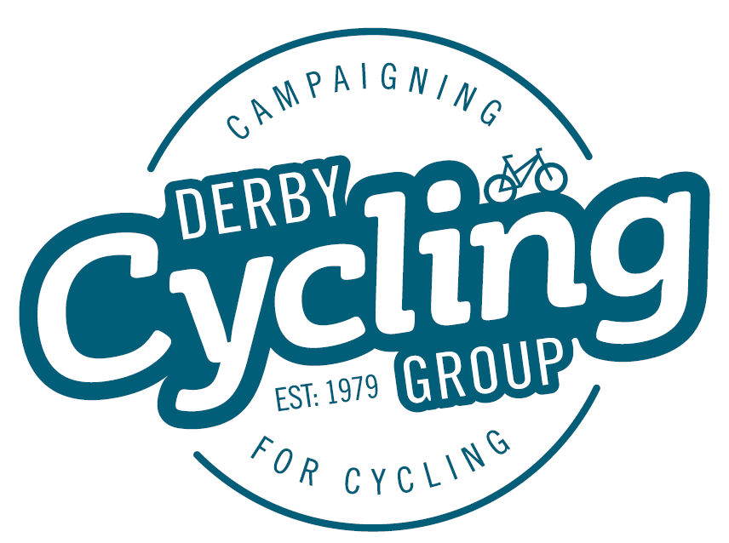
126, Station Road,
Mickleover,
Derby,
DE3 9FN

10th April, 2015

Dear Councillors,

Through our Space for Cycling campaign, Derby Cycling Group has provided you with a lot of information about :
- How cyclists feel about the inadequate cycle network in Derby
- People's fears of riding on the road which prevents many of them from cycling at all
- The advantages which more cycle transport would bring to individuals and to the city
- What you as councillors can do to make that better cycling environment happen.
- How more space can be created in our crowded city spaces for cyclists

Can you now tell us what practical cycle transport policies you will be putting forward in your manifesto to enable more cycle journeys if
your party is elected to run Derby City Council in May 2015, and which you will be pursuing in those wards where you have councillors elected.

We will then share those ideas with our members and the wider public.

Yours Sincerely,

Tony Roelich
Campaigns Co-Ordinator
On behalf of Derby Cycling Group

Derby Cycling Group is a member based organisation representing over 400 cyclists in Derby and the surrounding area which promotes cycling as a healthy, sustainable and cost effective means of everyday transport.

