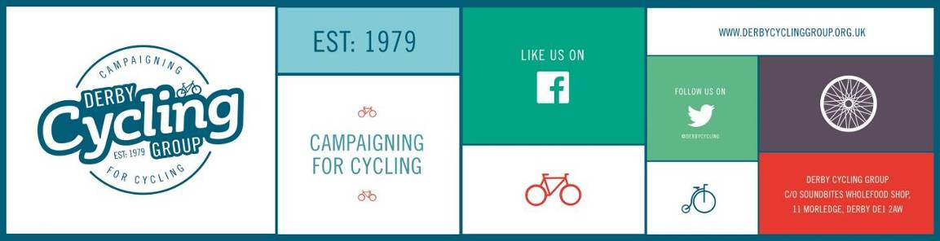

126, Station Road,
Mickleover,
Derby,
DE3 9FN

20th January, 2015

Dear Councillor,

Space for Cycling: What Councillors Can Do For Cycling in Derby

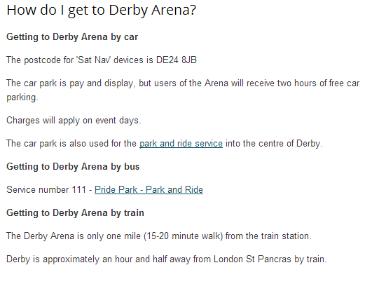
Cycle transport is not on the political agenda in Derby and it shows in the way that infrastructure is delivered here:

- A velodrome which has no cycle path connecting it to the busiest cycle path in the city. This cycle path should connect the velodrome, off road, to the whole of the eastern sector of Derby, but it didn't until Derby Cycling Group stepped in.

- An Arena whose Customer Information tells people how they can get there by car, train or bus – but not by bike or on foot!

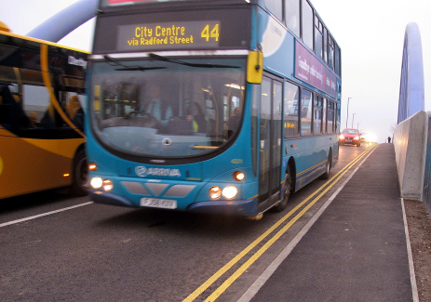
- An £11million bridge replacement project which provides absolutely no space at all for cyclists because the bridge is just one metre too narrow.

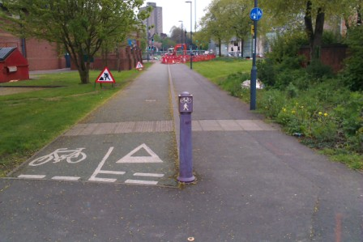
- A revolutionary new “urban village” close to the city centre featuring a traffic free boulevard at it’s focus, enabling people to walk and cycle unhindered between the railway station and the city centre – which has actually removed one of the best pieces of dedicated cycle infrastructure we had in Derby (similar to that on the left) and replaced it with – a road. What happened to the much vaunted Boulevard?

These examples are a travesty of transport planning in the 21st century.
You need to step up to the mark and give council officers in all departments a clear policy message – cycling is important, everyone should feel it is safe enough to cycle anywhere; cycling should be considered in every project you do; cycling infrastructure deserves to be done well in Derby.

Derby Cycling Group would like councillors to make clear cycle-focussed policy statements to your departments, your executives, your officers and your party leaders. Some of the ways you can do this are:

- Engage in a conversation about the cycle strategy
  - In every community across Derby there are cyclists with concerns about safety on the roads and ideas about what can be done to make things better. Seek them out and talk to them, find out what the issues are and what cyclists would like to be done to resolve them.
  - What can be done in your area? Derby Cycling Group members can help. Ask for input through us and through local community events.

- Set up a cross party select committee to review cycle needs and propose cycling policy
  - Instigate the creation of an integrated cycle network development plan to define what Derby’s cycle network should look like and the design standards to which it should be built.
  - Define policies which require all departments to identify and implement ways in which they can deliver greater levels of cycling.
  - Require that all infrastructure projects, planning applications, and developer proposals incorporate cycle audits as part of every stage in the planning review process.

- Integrate cycling development plans across all council departments
  - Planning and Development Control should:
    - Deliver the cycle network bit by bit through the planning conditions they set and section 106 funding contributions they secure.
    - Make sure planning conditions and section 106 funding contributions are strategic and are flexible enough to deliver the best overall solutions for a given area, or can be pooled together to deliver larger schemes serving several developments in a local area.
    - Police their planning conditions and section 106 contributions to make sure developers deliver cycle infrastructure to the design and standard required, on time and on budget – you know it doesn’t happen today.
  - Highways and Transportation should:
    - Ring fence funding for active travel and for Cycle Derby and make sure active travel has the highest priority in the transport hierarchy. This will ensure that cycle infrastructure continues to be delivered; the Active Travel budget is small but it must be protected.
    - Maximise the delivery of cycle infrastructure by incorporating it into scheduled road maintenance projects (eg road resurfacing or traffic signal replacement at junctions).
    - Get in touch with the latest cycle infrastructure designs which are safer and more cyclist friendly.
    - Support and develop the sustainable travel team to enable them to deliver more infrastructure projects.
    - Develop cycle infrastructure projects suitable for external funding and seek that funding to deliver the schemes.
  - Education should:
    - Identify route improvements to schools for children who want to walk and cycle to school and deliver them.
    - Encourage children and their parents to cycle to school
  - Public Health should:
    - Get people cycling as part of strategies to make people physically and mentally fitter and more healthy.
    - Promote cycling as part of a healthy lifestyle and most importantly – get people doing it.
    - Use cycling to get more people more healthy with the objective of reducing the cost of providing health care in Derby.

- Appoint a cycle champion to develop a cycling culture across the council:
  - With a cross-departmental remit
  - With powers to influence decisions and decision makers
  - To hold regular cycle forums with cross party political representation as well as cycle focussed organisations and departmental representatives.

- Seek cross party political support:
  - Cycling is so beneficial it should be embraced by all political persuasions
  - Agree on the high priority which cycle transport should have
  - Make cycling a strategic objective for all council directors of services
  - Make the development and integration of cycling a high priority for all council officers
  - Focus on delivering practical schemes that enable people, everyone, to cycle
  - Challenge officers to create a cycle strategy and deliver it
  - Support proposals to deliver more and better cycle routes

In our next letter we will show how some of these aspirations can be delivered and how they often cost very little to do. Many of the items above are just about doing something differently, not doing something extra; about thinking about cycling while developing other strategies and projects. Others, obviously, will cost more money but increasingly there are sources of funding available for cycling projects and Derby Cycling Group wants Derby to grab it's share.

The hard part is committing to the idea, so please take that step now and become part of the solution; please pledge your support by clicking on this Space for Cycling link.

Thank you,

Tony Roelich
Campaigns Co-ordinator
On behalf of members of Derby Cycling Group

Derby Cycling Group is a member based organisation representing over 400 cyclists in Derby and the surrounding area which promotes cycling as a healthy, sustainable and cost effective means of everyday transport.

