 Derby Cycling Group
Space for Cycling Information Sheet

“Space for Cycling” is a major national campaign.
It aims to raise the profile of cycle transport and the issues facing cyclists with local councillors and get them to pledge support for six Space for Cycling themes.

It is your chance to influence the development of cycling as transport in Derby.

Hopefully this leaflet will inform you of the recent history behind some significant cycle campaigns over the last coupe of years and provide you with information to begin lobbying your own councillors for better conditions for cyclists on Derby’s roads.

Derby Cycling Group and Space for Cycling
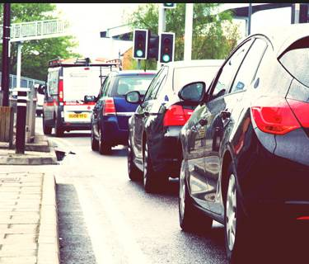
Despite Cycle Derby doing fantastic things promoting cycling, including their world class engagement with children and highly successful cycle sport development programs which have given us the national level BMX track, brought national cyclo-cross championships to Derby and now the velodrome at the Derby Arena, the rest of the city council lacks any sort of cycle strategy or plan. Bits and pieces of network are developed by a few heroes within the sustainable transport department with pitiful budgets, but it is a pathetic excuse for a modern cycle transport strategy. There is no cycling development plan worthy of the name that will actually develop a network to enable more people to travel around on a bicycle.

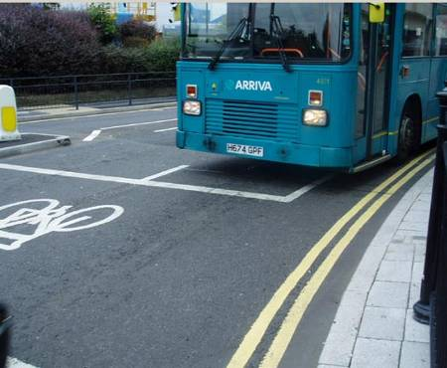
At DCG we want the city council to embrace and enable cycling for everyone for everyday journeys as well as promoting the notion of cycling.

At DCG we want all our councillors to pledge support for Space for Cycling and we want a cross-party consensus which actively promotes cycle-friendly policies across all council departments with the aim of creating a cycle network that enables anyone feel empowered to cycle anywhere in the city at any time.

Your Bit - Getting Involved
First up, just take ten minutes to do these three things…
- Watch the two minute video on Space for Cycling
- Scan through the Space for Cycling literature
- Prepare a letter for your local councillors and use the online tool to send it to each of them (prepare your letter beforehand and insert it over the standard letter, or in front of it)
Next, we’d love it if you could take it further – become informed and take part in a conversation with our politicians…
- Familiarise yourself with the background to recent national cycle campaigns and how they have raised the profile of cycle transport at a national, governmental level by reading the information and following the links further down this sheet, including:
  - The Times’ “Cities Fit For Cycling” campaign
  - The All Party Parliamentary Cycling Group report, “Get Britain Cycling”
  - David Cameron’s views on “Get Britain Cycling”
- Read the Space for Cycling literature in more depth
- Also write directly to your local councillor as well, to ask them to support more Space for Cycling in Derby (get their address and e-mail here)
- If living in Derby City, find out when and where your next Neighbourhood Forum is to be held, go along and ask all your councillors in person to support Space for Cycling and ask them to tell you what their cycle policies will be for the next election (they may need to get back to you on that one).
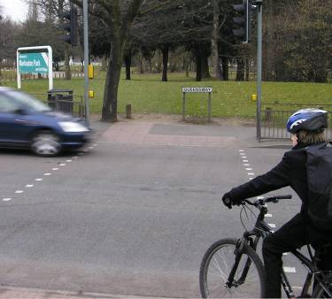
- If your councillors want to support the campaign they may want help to understand the issues and to identify solutions to them; offer to meet with them and take them an issues list and a wish list:
Some potential issues:
- Bad driving
- Speeding traffic
- Busy roads which are hostile to ride on
- Bike thefts
- Poor road surfaces

Some potential solutions:
- Cycle lanes and advanced stop lines on the road
- More off-road routes linking residential streets with local destinations
- Cycle paths alongside roads (but not shared use of narrow pavements)
- 20mph speed limits
- Cycle stands at all local destinations (shops, schools, places of work, doctors, churches, pubs … everywhere)
- Priority repairs for potholes that pose a specific danger to cyclists
- Let us know at DCG what you are doing so we can help to co-ordinate efforts across the city campaigns@derbycyclinggroup.org.uk
- Come to DCG meetings and get involved in taking the campaign forward (first Tuesday of every month, 7.15pm for 7.30 start at The Brunswick pub on Station Approach).

If you need help getting ideas to present to your councillors, please read on.
(E-mail campaigns@derbycyclinggroup.org.uk if you want help or advice)

Where Did “Space for Cycling” Come From?
There is a growing national promotion of cycle transport, which takes the notion that there are many, many good reasons why more cycling is good for individuals, for society and for the nation, but that many people do not cycle because they do not feel safe cycling on the road, and that this is not acceptable and things need to change.

Although cycling is safe it can feel risky; the road can feel a hostile place to those new to cycling or used to being cocooned in a steel shell and there are issues of poor driver training and a lack of benevolence towards vulnerable road users. However, huge progress has been made in raising the profile of the issues at a national level and getting tacit agreement that something must be done to address them. Some of the key milestones in this story have been:


- The Times: Cities Fit for Cycling campaign
The Times newspaper campaign derives from a serious injury to Times journalist Mary Bowers outside The Times newspaper offices while she was cycling to work. This lead to a series of front page stories, regular cycle promotional and campaigning articles, a dedicated Cities Fit for Cycling website and an 8 point manifesto for creating cities which were fit for cycling. The campaign was developed in partnership with and supported by CTC, Sustrans, London Cycle Campaign, The AA and many other national organisations. Nothing like this has ever been seen in the UK national media before. Here you can read that 8 point manifesto.

- The All Party Parliamentary Cycling Group: Get Britain Cycling Report
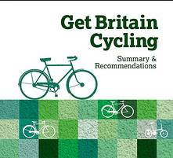
Funded by The Times newspaper, the APPCG initiated a parliamentary committee report into what needed to be done to make the conditions right to develop cycling as a mainstream means of transport for the whole population (to “Get Britain Cycling”) and why that is important.
  - Jan to March 2013: Committee stage with dozens of expert witnesses from the field of cycling, road transport, health, and many other areas including Jon Snow (CTC president), Chris Boardman, Edmund King from The AA, Sustrans, Institute of Advanced Motorists, Road Freight Transport Association.…. see the full list of witnesses

  - April 2013: The publishing of the Get Britain Cycling report (summary or full report ) , based on the evidence from the committee stage
  - 2nd September 2013: Over 100 MPs from all parties debated the Get Britain Cycling report and unanimously voted to support it. Here is one report on it from BikeBiz and another from CTC. Meanwhile, only a handful of MPs were debating other business in the main House of Commons chamber.

- Prime Minister David Cameron backs a “Cycling Revolution”
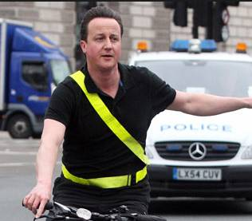
On 25th April, 2013 David Cameron commended the Get Britain Cycling report in the house of commons and gave his personal approval to the aspiration to enable the growth of cycle transport. However, he then said that this revolution would be delivered by local authorities (over which he has no direct influence) and he did not provide any funding to enable local authorities to do it.

That is where the Space for Cycling campaign started. Originally it was an idea by the London Cycle Campaign, as a way of enabling it’s members to lobby their council candidates at local elections about getting policies that support the growth of cycling in London. This has been taken nationwide by the CTC, Cyclenation, The Bicycle Association and other organisations.

And that is where you, we, the members of Derby Cycling Group come in. You need to show your own councillors that cycle transport matters, that there are votes to be won by supporting cycling (or lost by not supporting it). The Space for Cycling Campaign has been designed to help you do that.

Space for Cycling:

The best introduction to the national Space for Cycling campaign is:
CTC Space for Cycling

There are also the excellent materials provided by the London Cycle Campaign which include campaigning ideas and support:
LCC Space for Cycling

The Space for Cycling campaign provides:
- Six themes around which action is needed to help cycling in Britain to grow:
- Protected space on main roads
- Removing through motor traffic in residential areas
- Lower speed limits
- Cycle-friendly town centres
- Safe routes to school
- Routes through green spaces
- Resources and materials to help us promote cycling and the Space for Cycling campaign with local councillors including online videos, booklets, fliers and written articles.
- A web tool which tells you who your local councillors are, where you can write to them online to tell them of the importance of cycle transport and urge them to pledge their support to the campaign
- An associated online form where councillors can pledge their support to the Space for Cycling campaign
- An online map showing how many letters have been sent to the members of each council and which councillors have pledged their support for Space for Cycling.

The Future : the Funding for Cycling campaign
The CTC and other national cycle campaign organisations are taking the Space for Cycling campaign further and are campaigning hard for the government to provide £10 per head per year to fund cycling in Britain. That is a small part of the total transport budget, but is essential to enable the conditions on our roads to be improved for the benefit of cyclists. With £10 per head per year , as in Holland, Denmark and many cities across the world, that level of funding will make a real difference and will get more people cycling more safely more often.

Derby Cycling Group Cycle Strategy
DCG has an idea of what a dedicated, interconnected cycle network would look like and how it would work in Derby. Once we get councillor’s support we will begin working with them and council officers to get our aspiration put into practice. Let us know what you think we should include in that strategy:
- General principles, design strategy, etc
- Specific solutions to specific places or problems
Write to campaigns@derbycyclinggroup.org.uk including “DCG Cycle Strategy” in your subject. If you can attach a word document to explain what you think it will make it easier to send to other people and print for review at meetings etc.

What ever you do, please, get campaigning.

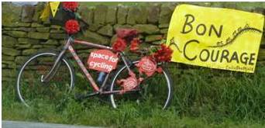

Derby Cycling Group meetings – first Tuesday of every month 7:15 for 7:30pm start, Brunswick Pub, Station Approach, Derby. Everyone welcome to join the conversation.
E-mail campaigns@derbycyclinggroup.org.uk to discuss any cycling issue in the Derby area.
V3

